Business Class Email

Overview

Contents

Messaging 2
Quick Pitch 2
Top-line Benefits 2
Supporting Statistics 2
Detailed Benefits 2
Features 3
Customer Experience 4
Sales Support 6
Probing Questions 6
Selling Points 6
Competitive Information 6
Objection Handlers 6
Frequently Asked Questions 8

Messaging

Quick Pitch
Business Class email is a secure and reliable domain-name based email solution. It has features for users on the go, while allowing businesses to look professional with an email address that represents their business.
Having a domain-name based email helps to build trust with customers and keeps their business name top of mind. Think about typical email interactions; when receiving emails from an address that does not include the company’s name (ex. @gmail.com), does that inspire trust and confidence? Our solution is designed to help businesses put their brand at the heart of everything they do including communications.
Our web-based email solution is more affordable than the competition and includes the necessary productivity features businesses need to run their business more efficiently. Users can manage their time more easily by turning emails into tasks so they always meet their deadlines and improve productivity with the multi-inbox view so they can see all email accounts in one place.

Top-line Benefits

Improve productivity: multi-inbox view to manage all email accounts.
- Time Management: Turn emails into tasks, add collaborators and set due dates and reminders.
- Look Professional: Having a custom domain-based email address makes businesses seem established even if it’s just starting out.
- Peace of mind: Large mailbox sizes to meet your customer’s needs.
- Customized email: With ISP email and business class email, service providers can customize which email type and features they choose to go to market with.

Supporting Statistics

Domain-based email builds trust: 75% of consumers say professional email addresses are key to trust. (Mailbird, 2022)

Increase brand awareness: 60% of businesses that switched to a custom domain-based email saw an increase in customer engagement. (Privy, 2022)

Get more sales: 42% of businesses that switched to a custom domain-based email saw an increase in sales. (Privy, 2022)

Detailed Benefits

Makes a Business seem large | - Having a domain-based email makes a company look established even if they are just starting out.
Builds Trust | - Contacting customers through a branded email builds trust because businesses are contacting them as a corporate entity.
Improve productivity | - Multiple inboxes allow businesses to manage all email accounts in one place.
Easily manage time | - Turn emails into tasks, set due dates and reminders.
Look Professional | - Using domain-based email instead of Google or Microsoft adds a layer of professionalism because the communication is coming from a business.
Help customers find a business website | - Business email contains a domain name so customers can always find the website.

Features

Custom Address | - Businesses have professional representation with an email address that matches their business domain name. It promotes the brand and helps them stand out from the competition.
Calendaring | - Webmail makes managing calendars a seamless process.  - First customers need to create a calendar, in the calendar menu select the create a new calendar icon, fill in the information i.e. name, colour, sharing options and permissions.  - Calendar preferences: default calendar view, change first day of the week, option not to show weekend in the calendar, set free/busy/ custom hours.  - Events:  - Create an event: Click create new event icon or select a day from the calendar view. Enter a title, time, recurring timeline, location and attendees.  - Locations: Default Location- set the default location for events, Show default location, Allow collection of used location, Clear location history  - Shared Calendar  - Create a shared calendar: Customers can create multiple calendars and share with other accounts on the same domain. Read only and edit events options allow other users to view and/or edit calendar information once they have subscribed. The owner of the calendar can set editing and viewing permissions.  - Subscribe to a shared calendar: These are calendars other users have shared. If a calendar has been shared with a user, it will appear in the subscribe to calendar list. Under calendar, click the plus icon under shared calendars. select the calendar.  - Share a Calendar: Any calendar created can be shared with other users on the domain. Users can choose to turn a private calendar into a shared calendar. Users can go to the settings and use the drop down menu to select do not share, read only, read, edit and delete events. By selecting do not share other users can see the customer is busy but cannot see the activity.
Ad Free | - Webmail is completely ad free. Stay focused on work and don’t get distracted by ads.
Themes | - Create a custom experience. Change the color or background image to personalize any inbox.  - Under General, select change theme
Set up POP/ IMAP in Outlook | - Under account settings go to advanced options and select POP or IMAP. There is also an option for an encryption method if the server allows secure connections (SSL).
Security | - All email is safe and secure. It comes with advanced anti-virus and anti-spam protection and 24/7 monitoring.  - There are many ways to adjust SPAM settings  - Spam filter strength allows customers to turn on spam filtering and specify the level of filtering applied. Every email received through the inbox is run through a point based spam filter based on subject, message formatting and message headers. There are three levels of filter strength.  - Light: sets the spam filter to a low sensitivity level. It will let through more spam but is less likely to accidentally identify a legitimate email as spam.  - Standard: (Recommended): Sets the spam filter to a hight sensitivity level. This setting has a 95% - 99% success rate for differentiating between spam and legitimate emails. This is the default setting.  - Aggressive: sets the spam filter to a very high sensitivity level. This setting increases the chances of legitimate emails being classified as spam.  - Filter outcome- choose whether to delete, tag & deliver or quarantine spam emails.  - Trusted senders  - Users can add trusted senders to the list so their emails will always get through regardless of spam configuration.  - Spam senders  - Users can add email addresses to this list and they will never receive emails from that email address regardless of spam settings.
Task box | - Turn emails into categories, assign tasks, set reminders, and add due dates to emails.  - Create tasks: set task name, set due date, add a tag to help identify or search for the task, subtasks can also be added to the task, add collaborators by entering the name or email of the person involved with the task. Add attachments to the task by clicking the attachment icon and uploading the file. Add notes and/or a brief description of the task.  - Edit/delete tasks: From the task list, click the task that needs editing, it will open, once changes have been made click save. To delete, select the task(s) to be deleted and click the trash icon.  - Archive a task: Select the task and click the archive icon.  - Turn emails into tasks: Enable taskbox tagging in the inbox and save changes. Select the email to turn into a task and under tags select: to do, pending, priority, future or reference. From the inbox customers can filter emails to see tagged tasks.
Manage inbox | - Change inbox view  - Vertical split pane  - Horizontal split pane  - Horizontal full page  - Filter inbox  - Manage inbox (trash, spam, tag task, move to alternate folder)  - Send email  - Add placeholders to messages  - Pull contact information from contact list. Select any or all of the options i.e. contacts full name, work phone, mobile phone, address and more,  - Add calendar availability in message  - Manage folders and subfolders  - Mail sorting and snippets  - Display emails by ID, Date, Sender, Subject or Message size.  - Display email threads  - Search inbox  - Manage attachments  - Send an email to a group

Customer Experience

Once the domain and email package is purchased, the customer will receive a welcome email with their portal login information. When they login they will see add email under the quick access apps.
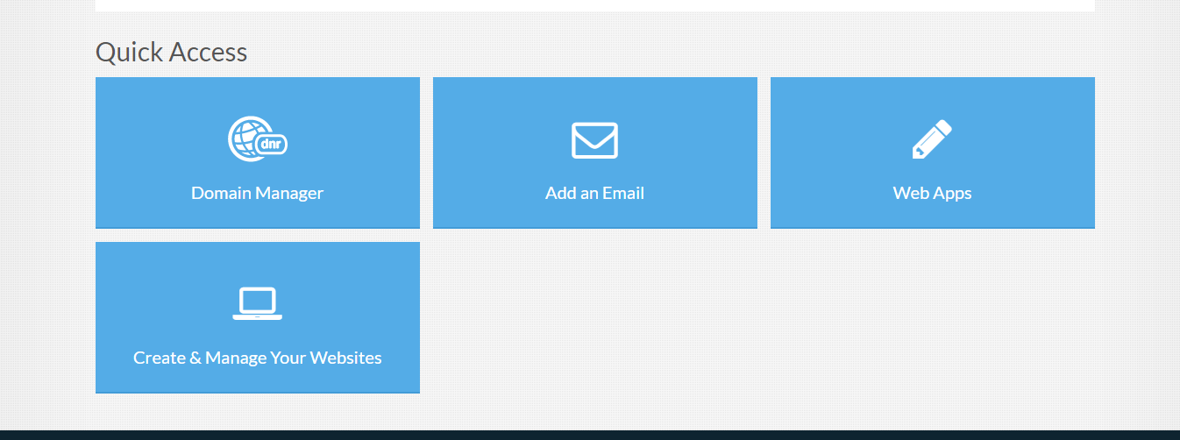
Click on add an email, they will see the existing mailbox and can click add new email account.

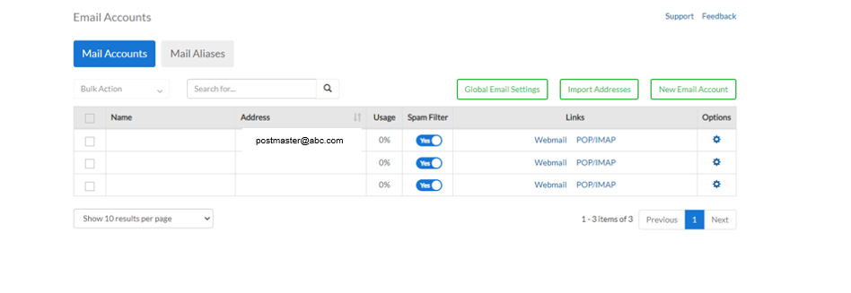
Fill out the name on the email and from here forwarding to another email address can also be set up.
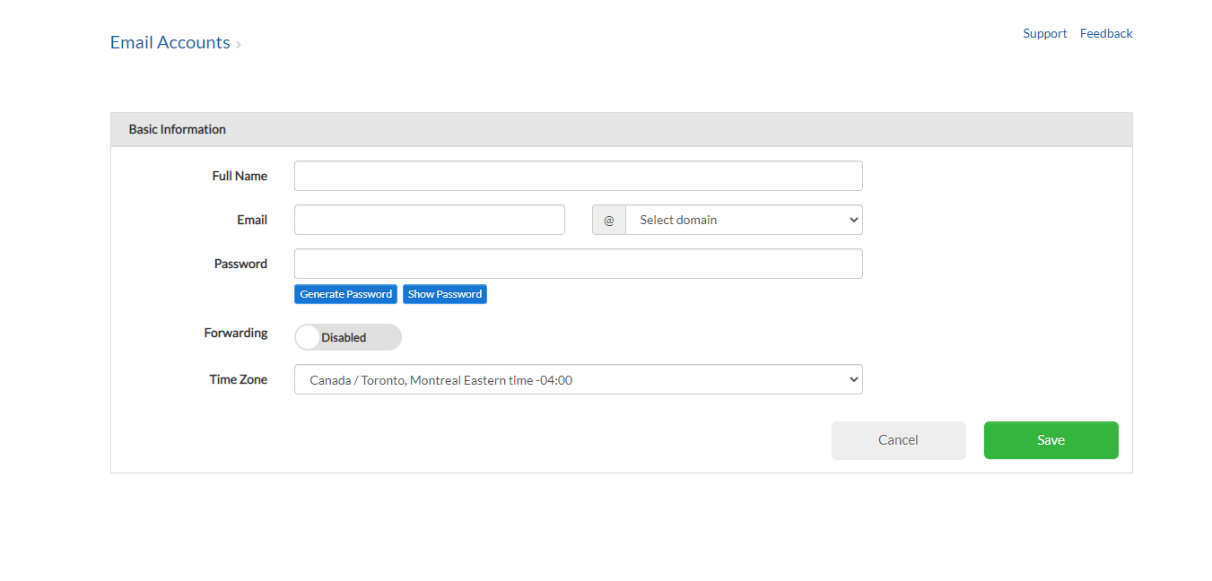

Sales Support

Probing Questions
I noticed you don’t have domain-based email. You should be promoting your business instead of Google and Microsoft. Why haven’t you made the switch yet?

Having a domain is the best way to start building your brand. Customers will see your business name at the end of your email address and begin to associate it with you and your business.

How much are you paying for Google Workspace or Microsoft 365?

These costs add up and they bundle a lot in their plans that many people don’t use or need. Our solution is cost effective and efficient.

Are you looking for a way to manage all your emails?

Our service allows you to easily manage your multiple email boxes. You can even turn emails into tasks and set due dates, so you stay on top of everything.

Selling Points
Connect with customers: Connect with customers by using your domain email.
Professionalism: Business email enhances your professional image
Ownership: You own the domain name and email so even if you change providers, you still will still have the same email address. This is not the case with Google or Microsoft email addresses.

Competitive Information
How do our email plans compare to other email services?

See Competitive Analysis

Objection Handlers
I don’t want a new email, I’d rather use my personal.

Having a domain-based email makes you look more credible as a business and builds trust with your customers.

I am comfortable with the current email service I am using.

That’s great you are enjoying your current service. Having a domain-based email address puts your business in the mind of your customers every time you reach out. You don’t have to question if it is coming from that company. Think about it, if a well-known business, like Starbucks reached out to you with a gmail.com email address would you trust that it is actually from them?

It’s going to be too complicated to start using a whole new email system.

Our system is easy to use, and web based so you can access it anywhere you have an internet connection.

Why would I pay for an email service when gmail is free?

A company branded email address is worth having credibility.

We have a lot of turnover and new employees, so I don’t want to go in and delete old users and add new ones.

While you can choose to have individual email addresses for each employee you can also just have one main email like sales, contact or info at your domain.

We don’t have the time.

The email system is easy to set up and use. You can add and remove emails with ease, manage your calendar and create a customized experience all from your email portal. Having a web-based email solution means you can access your email from anywhere that has an internet connection.

Frequently Asked Questions

What is domain-based email?

Domain-based email is an email address ending in your domain name i.e. sales@domain.com. This email will represent your brand every time you contact your customer and keep your business top of mind.

What is included in the email plans?

With our email plans you get a mailbox, anti-virus, anti-spam filters, ad free, ability to customize your experience, integrate with the calendar and easily add and remove users.

How do I choose the right email package for my needs?

We have a variety of different packages for you to choose from. Pick one that best suits you by considering how many employees need email and how the email will be used ie. Communicating with clients or sending large files. This will give you the best idea on which plan is best for your business.

How does it compare to other domain-based email services?

Many of our website plans include a domain-based email address and have offers to add on additional mailboxes.

If I have a domain with another provider and I want to keep it there or register it with you, how do I do that?

Our technical support can walk you through that process when you are ready to move your mail accounts over to us.

How do I share a calendar with my team?

Very easily! Go to share with domain users and select: read only or read, edit and delete events. Now everyone with an email on the same domain will be able to access the file. Alternatively, to share with one user, enter the email address under share with specific users and choose the permission type.

I have a customer whose emails keep going to spam. How do I ensure I always receive their messages?

I understand it can be frustrating when you are waiting on an email and it gets sent to spam. The easiest way to ensure you receive all emails from a particular email address would be to add their email to the trusted senders list. This will let their emails through to your mailbox regardless of spam settings.

Can we brand the inbox with our business name for our users?

We include many different themes as part of our email packages. If you would like to change the color or background image, we have the capability.

